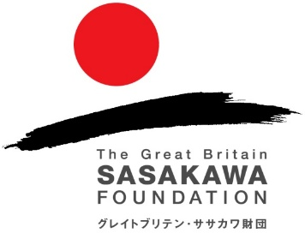

The Great Britain Sasakawa Foundation

Grant application form

Please email this application form to: grants@gbsf.org.uk
Attach any supporting material separately. Limit the form to two pages of A4.

Organisation:
Lead applicant name:
Email:
Telephone:
Address:

Project title:

Select one from the seven following categories that you feel best represents your project. Paste it in the bottom right cell.

Arts and Culture | Science, Technology and Environment
Humanities and Social Issues | Japanese Language
Medicine and Health | Youth and Education
Sport | My project category:

Please provide an overview of your project. In 150 words or less

What is your project schedule? We are unable to consider applications for projects that start before the decision date.

DATES | ACTIVITY
e.g. 10th – 13th April (tbc); Jun-Sept 2025 | e.g. Conference in Tokyo; Consultation phase
Add more rows to the table if necessary.

What is new or significant about this? In 150 words or less

What will be the impact and on how many people? In 150 words or less

How will the continuity of the project be guaranteed in the future (if appropriate)? In 150 words or less

Please attach a detailed project budget as a separate document. Clearly indicate using the table below which elements you request our grant support for.
ITEM | COST (IN £)
e.g. UK-Japan return flights; 5 days subsistence
Add more rows to the table if necessary.

What other sources of financial support are anticipated? Please give amounts where appropriate
CONFIRMED
APPROACHED

Have you applied to the Great Britain Sasakawa Foundation before? Include dates and amounts awarded, if successful

If you are a first-time applicant, how did you find about the Great Britain Sasakawa Foundation?

Do you plan to promote your project activity on social media? If applicable, please list any social media accounts and handles you expect to use.

You can include any further details you feel are relevant to your application below.

Name & date:

----------------------------------------------------------------------------------------------------------------------------
Thank you. Please email this application form to: grants@gbsf.org.uk

On receipt we will confirm whether it will be considered for an award. Awards Meetings are held in March, May and November. The deadlines for applications are 15th December, 31st March and 15th September. We regret that we cannot make retrospective awards.

NB: The acceptance of a grant application does not imply any obligation on the part of the Great Britain Sasakawa Foundation and applicants should not make any commitments in anticipation of an award.

The Great Britain Sasakawa Foundation, Lower Ground Floor, 24 Bedford Row, London WC1R 4TQ
Tel: 020 7436 9042 Website: http://www.gbsf.org.uk

