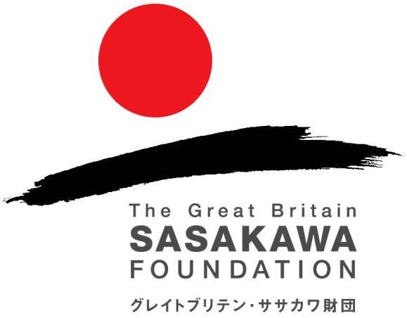

Butterfield Awards for UK-Japan collaboration in

medical research and public health practice

Application form

Name/title of applicant:

Contact details:

Name of applicant’s institution/professional base:

Names and contact details of two professional referees:
(Please attach two references to your application – both should be external referees and not based at either your institution or your project partner’s institution)

Name and contact details of partner/host in Japan/UK:
(please attach evidence of host’s readiness to facilitate exchange and collaboration)

Field of research:

Outline of project/exchange/collaboration:
(attach detailed proposal separately)
When will the project take place? Who will participate? What facilities will be provided by the host/partner?

What is the importance of this field of research at this time for UK/Japan?

How far is this project breaking new ground?

What are the significant planned outcomes? How will these be assessed?

How will the continuity of the project be guaranteed in the future?

Total project budget (please attach a detailed project budget)

Amount requested from the Great Britain Sasakawa Foundation:

For which elements of the project budget are you requesting our grant support?
(NB The Foundation prefers to support identifiable activity and outcomes rather than general expenses).

What other sources of financial support are anticipated? (Please give amounts where appropriate)

Confirmed:

Approached:

Have you applied to the Great Britain Sasakawa Foundation before?

If so, give dates and amounts awarded, either for a Butterfield Award or regular grant, if successful.

If you are a first-time applicant, how did you find about the Great Britain Sasakawa Foundation?

Please identify the UN’s Sustainable Development Goals (https://sdgs.un.org/goals) this project supports:

Signature & date:
----------------------------------------------------------------------------------------------------------------------------

Thank you. Please email this form to grants@gbsf.org.uk

The deadline for applications is 15th December for awards to be made in early March of the following year and for projects beginning no earlier than 15th March. On receipt of this form we will confirm whether your application will be considered for an award.

NB The acceptance of a grant application does not imply any obligation on the part of the Great Britain Sasakawa Foundation and applicants should not make any commitments in anticipation of an award.

The Great Britain Sasakawa Foundation, Lower Ground Floor, 24 Bedford Row, London WC1R 4TQ
Tel: 020 7436 9042 Website: http://www.gbsf.org.uk

